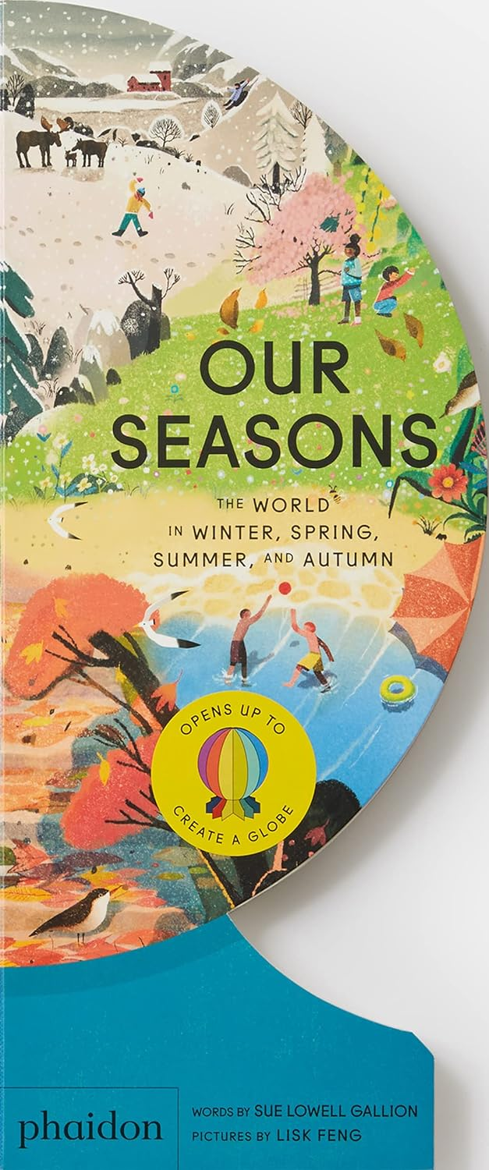

**A teacher’s guide**

**created by Marcie Colleen**

**based upon the book**

**written by Sue Lowell Gallion**

**and**

**illustrated by Lisk Feng**

This classroom guide is designed for students in kindergarten through second grade. It is assumed that teachers will adapt each activity to fit the needs and abilities of their own students.

It offers activities to help teachers integrate *Our Seasons: The World in Winter, Spring, Summer, and Autumn* into the curricula.

All activities were created in conjunction with the Common Core and other relevant content standards.

***

Guide content copyright © 2024 by Marcie Colleen. Available free of charge for educational use only. May not be published or sold without express written permission. [www.thisismarciecolleen.com](http://www.thisismarciecolleen.com/).

To learn more about Sue Lowell Gallion, visit her at [www.suegallion.com](http://www.suegallion.com). To learn more about Lisk Feng, visit [www.liskfeng.com](http://www.liskfeng.com).

**Before You Read…**

Before reading *Our Seasons: The World in Winter, Spring, Summer, and Autumn…*

Look closely at the illustrations on the front and back ~

* Read the title aloud.
* Describe what you see.
* How would you describe the shape of the book?
  + Why do you think this shape was chosen?
  + Brainstorm other possible shapes that would be suitable for a book about seasons.

**English Language Arts**

**Reading Comprehension**

Now read or listen to the book.

Help students summarize in their own words what the book is about.

* What is your favorite part? Explain why.
* Did you learn anything new that you didn’t know about already?
* The text is written in two parts: in rhyme on the left side and in deeper explanation on the right side.
  + Why do you think the author chose to write the book in this way?
  + Read through only the rhyming part of the book.
  + Then read through only the informational part of the book.
  + Which do you prefer and why?

Let’s talk about the people who made *Our Seasons: The World in Winter, Spring, Summer, and Autumn.*

* Who is the author?
* Who is the illustrator?
* What kind of work did each person do to make the book?

Now, let’s look closely at the illustrations. Can you find:

* A bird nest in a tree
* A black dog
* A red umbrella
* Five baby chickens
* Three bumblebees
* A cardinal
* Two seagulls
* A rabbit
* A baby moose
* A snowperson in the making
* A sleeping bat
* A backyard swimming pool
* Three friends on bikes
* The equator

**Reading Nonfiction**

While reading *Our Seasons: The World in Winter, Spring, Summer, and Autumn*, take notes in two columns:

* + *Things We Learned*
  + *Questions We Have*

Pause before each page turn to add notes to the columns. These columns can either be individual or hung on the board and worked on as a class.

|  |  |  |
| --- | --- | --- |
| Things We Learned (Facts) | Questions We Have | Answers We Found |
|  |  |  |
|  |  |  |

* Once the story is read, discuss the *Questions We Have* column.
  + Were any of these questions answered as the story went along?
  + If so, find the answer within the text.
  + Record the answer next to the question in a third column labelled *Answers We Found.*
* For all remaining questions in the *Questions We Have column*, that have yet to be answered, take the steps to find answers, either through Internet or book research.
  + Discuss how to find answers to questions through research.
  + Assign students to specific questions to help them focus.
  + Record all answers in the *Answers We Found* column.
* After the answers have been shared with the class, engage in a discussion on research practices.
  + What was the most difficult about finding answers?
  + Was it easier to find answers on the Internet or in a book?
  + Which type of source do you think is more reliable, the Internet or a printed book? Why?
  + How can you determine whether to trust a source?
  + What tips would you give someone who is about to do research?

*Extension:* Design and illustrate posters representing each Fact, Question, and researched Answer based on *Our Seasons: The World in Winter, Spring, Summer, and Autumn* and display them within the classroom.

**Make Your Own Nonfiction Book**

With paper, tape, and scissors create your own nonfiction book about the four seasons with novelty elements like lift-the-flaps, cut-outs, or pop-ups. Maybe construct your book using a non-traditional shape to best convey your topic.

**Write the Scene**

Choose one of the illustrations in *Our Seasons: The World in Winter, Spring, Summer, and Autumn* and create the scene. For example,

* What do you see?
* How did it start?
* Who is participating?
* What do they say?
* What happens next?
* How does it all end?

Be sure to include a beginning, middle, and end.

**Seasons Acrostic Poems**

*Our Seasons: The World in Winter, Spring, Summer, and Autumn* is filled fun descriptions about the different seasons.

Acrostics are a fun poetic form that anyone can write. They have just a few simple rules.

To begin with, an acrostic is a poem in which the first letters of each line spell out a word or phrase. The word or phrase can be a name, a thing, or whatever you like.

Usually, the first letter of each line is capitalized. This makes it easier to see the word spelled out vertically down the page.

Acrostics are easy to write because they don’t need to rhyme, and you don’t need to worry about the rhythm of the lines. Each line can be as long or as short as you want it to be.

To create an acrostic about the seasons, follow these easy steps:

1. Write WINTER, SPRING, SUMMER, or AUTUMN down *vertically*.
2. Brainstorm words or phrases that describe each season, taking inspiration from the text and art in *Our Seasons: The World in Winter, Spring, Summer, and Autumn*, as well as your own experiences.
3. Place your brainstormed words or phrases on the lines that begin with the same letters.
4. Fill in the rest of the lines to create a poem.

Decorate your poem with photos or drawings of the season and hang it up somewhere to display.

**Science**

**Nature Journaling**

“Instructions for living a life. Pay attention.  
Be astonished.  
Tell about it.” Mary Oliver, Mornings: Poems. Penguin Books. 2013

As a class, discuss the poem.

* What might the poem mean, in your own words?
* What do you think it would look like to follow the advice in Mary Oliver’s poem when experiencing the seasons? Explain your answer.
* Show examples of “paying attention” in *Our Seasons: The World in Winter, Spring, Summer, and Autumn*.
* Show examples of being astonished.
* In what ways can you follow Mary Oliver’s advice in this current season?

Create a Nature Journal:

* Gather together 6-8 pieces of paper (some can be lined for writing, others blank for drawing). Add on top a piece of blank paper for the cover.
* Punch three holes through the pieces of paper and the cover sheet.
* Cut a piece of cardboard just a bit larger than your paper.
* Punch three corresponding holes in the cardboard.
* Place the papers on top of the cardboard and top everything with the cover sheet.
* Line up the paper and cardboard holes. Then tie together with yarn or string.
* Copy Mary Oliver’s poem onto the cover sheet and decorate.

You are now ready to head outside and observe nature.

* Find a “sit spot” outside where you can sit quietly and observe. Be sure to have your Nature Journal and something to write with. You may use colored pencils, crayons, or markers if you prefer.
* Sit for at least fifteen. You may set an alarm.
* Look all around you. What do you see? What do you hear? What do you smell? What do you feel?”
* Find something you want to write about or draw and record it in your Nature Observation notebook.
* Continue to observe nature in the same spot, fifteen minutes at a time, for a whole week. Every day, take care to notice something different to write about or draw.

“Tell about it.”

* Share your notebook with the class.
* What did you find when you paid attention?
* What did you feel? What did you smell? What did you hear? What do you see?
* What astonished you?
* If you were to continue observing nature, what spot would you choose? Why?

**Seasons of Stories**

Gather fiction and non-fiction books, newspaper articles, internet clippings, videos and any other form of media about the four seasons.

After reading a story about a certain season, discuss

* The different holidays in that season.
* The different weather in that season.
* The activities to enjoy doing during that season.
* The clothes worn in that season.
* The way trees and plants look in the school’s town/city that season.

After the discussion, each student will draw a picture of their favorite season. They will write one sentence describing their picture.

**Seasonal “Weather!” game**

Think of each of the four seasons.

What are some of the activities you do most in each season? (Going to school, playing football, raking leaves, etc. in fall; swimming, going to camp, etc., in summer; playing Little League, planting a garden, etc., in spring; shoveling, skiing, playing hockey, etc., in winter.)

What kinds of weather do we tend to have in each season? (sunshine, thunderstorms, heat in summer; fog, hurricanes, cool in fall; snow, sleet, icy winds in winter; rain, warmth in spring.)

1. Pick a season to start the game.
2. Think of an activity that is done in that season and begin to act it out.
3. When the teacher calls out, "weather!" some kind of typical seasonal weather will take place and everyone must react appropriately.

Repeat this with each season.

*Optional:* put a lot of stress on the senses. What does the weather sound like? Feel like? Does it have a smell? A taste? What do you see?

**Habitats Are Communities**

Although animals can live in a home (i.e., birds live in nests) habitats are more like communities instead of “houses”. In fact, the plants and animals that live together form/ are called a community.

Within a habitat, there can be a variety of animals. Some animals need a large space to live in, while others need a smaller space.

Consider different habitats, from farm to tundra and grasslands to understand the importance of both living and nonliving things in a habitat and how animals and plants have adapted in order to thrive where they live.

To survive in its habitat, an animal needs five things:

Food

Water

Shelter

Air

Place to raise young

If the animal’s needs cannot be met, they relocate to another area. For example, if deforestation (removal of trees) occurs, a bird may relocate to another forest. When habitats become scarce (such as forests), animals risk becoming endangered.

* Have students study the art in *Our Seasons: The World in Winter, Spring, Summer, and Autumn*. Ask the following questions:
  + What kind of habitat do you see?
  + How do the living things in this habitat find their food?
  + What types of homes are found in this habitat?
* Lead a discussion about the students’ habitats and what items in their homes or neighborhoods support good health and the well-being of their families.
* Have each student create a drawing or model of their own habitat.

**Math**

**A Year of Seasons ~ a calendar counting activity**

A calendar can be a great way to introduce number recognition, counting and number sequencing.

Show the class a calendar. Ask for volunteers to point to different features, including the year, the names of the days, and the names of the months. Then use the calendar for a whole class counting exercises.

* Count the number of days in a week.
* Count the number of days in a month.
* Count the number of months in a year.
* Leaf through the calendar to see if all the months have the same number of days.
* Count backwards as you point to the numbers on a page in reverse order.

Once students are familiar with the calendar, cut out all the pieces of the calendar and have the class re-create it.

Add holidays and class birthdays to the calendar. Add seasons.

Place text or art from *Our Seasons: The World in Winter, Spring, Summer, and Autumn* on the calendar.

## **Symmetry of Nature Activity**

Introduce symmetry in shapes like a square, circle or triangle.

Define and discuss the line of symmetry, as well as the concept of a shape having more than one line of symmetry or no line of symmetry at all.

Using die-cuts from colored paper, have students fold the shapes along their line of symmetry.

Display the shapes with the folded line of symmetry on a bulletin board tree, dubbed a "symme-tree".

Snowflake Symmetry

No two snowflakes are alike, but they do have symmetry!

Using a blank sheet of white paper, students will fold it in half and cut a shape freehand into the paper from top to bottom.

Unfold to reveal a unique, yet symmetrical snowflake!

Butterfly Symmetry

Give each student a white paper cut out of a butterfly.

Students should draw a line down the middle of the creature or do it for them ahead of time. This line is the line of symmetry.

Then, using crayons or colored pencils and challenge the students to color the butterfly’s two wings in a symmetrical fashion.

OR

Using heavy paper, create large cut outs of butterflies.

Each student will fold their butterfly in half.

Then, unfold the paper and use finger paint to create a pattern on one wing of the butterfly, then refold the paper, pressing the paint onto the blank side of the sheet of paper.

When the butterfly is then unfolded, each wing will be symmetrical.

Allow to dry thoroughly before displaying.

What other seasonal nature has symmetry? Can you create them in the same way?