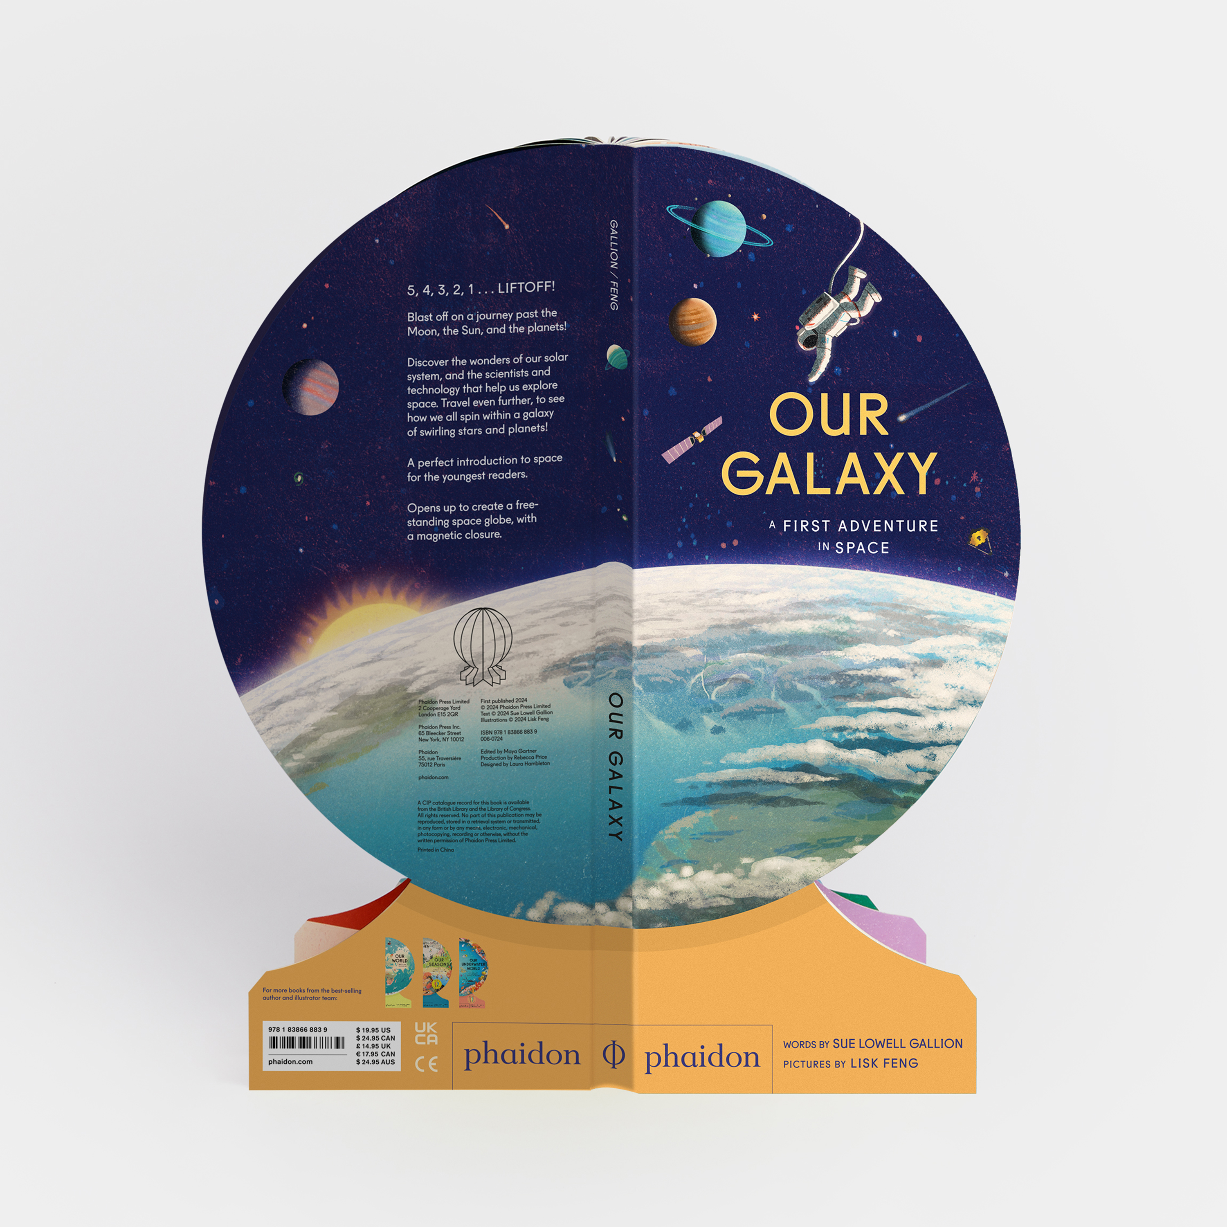

**A teacher’s guide**

**created by Marcie Colleen**

**based upon the book**

**written by Sue Lowell Gallion**

**and**

**illustrated by Lisk Feng**

This classroom guide is designed for students in kindergarten through third grade. It is assumed that teachers will adapt each activity to fit the needs and abilities of their own students.

It offers activities to help teachers integrate *Our Galaxy: A First Adventure in Space* into the curricula.

All activities were created in conjunction with the Common Core and other relevant content standards.

***

Guide content copyright © 2024 by Marcie Colleen. Available free of charge for educational use only. May not be published or sold without express written permission. [www.thisismarciecolleen.com](http://www.thisismarciecolleen.com/).

To learn more about Sue Lowell Gallion, visit her at [www.suegallion.com](http://www.suegallion.com). To learn more about Lisk Feng, visit [www.liskfeng.com](http://www.liskfeng.com).

**Before You Read…**

Before reading *Our Galaxy: A First Adventure in Space…*

Look closely at the illustrations on the front and back ~

* Read the title aloud.
* Describe what you see.
* How would you describe the shape of the book?
  + Why do you think this shape was chosen for this book?
  + Brainstorm other possible shapes that would be suitable for a book about the outer space.

**English Language Arts**

**Reading Comprehension**

Now read or listen to the book.

Help students summarize in their own words what the book is about.

* What is your favorite part? Explain why.
* Did you learn anything new that you didn’t know about already?
* The text is written in two parts: in rhyme on the left side and in deeper explanation on the right side.
  + Why do you think the author chose to write the book in this way?
  + Read through only the rhyming part of the book.
  + Then read through only the informational part of the book.
  + Which do you prefer and why?

Let’s talk about the people who made *Our Galaxy: A First Adventure in Space.*

* Who is the author?
* Who is the illustrator?
* What kind of work did each person do to make the book?

Now, let’s look closely at the illustrations. Can you find:

* A kid running with a toy rocket
* A giant telescope
* 7 people watching a rocket launch
* 2 astronauts
* 8 planets orbiting the Sun
* A Mars rover
* An astronaut on a space walk
* 3 planets with rings
* 6 satellites
* A moon halo

**Reading Nonfiction**

While reading *Our Galaxy: A First Adventure in Space*, take notes in two columns:

* + *Things We Learned*
  + *Questions We Have*

Pause before each page turn to add notes to the columns. These columns can either be individual or hung on the board and worked on as a class.

|  |  |  |
| --- | --- | --- |
| Things We Learned (Facts) | Questions We Have | Answers We Found |
|  |  |  |
|  |  |  |

* Once the story is read, discuss the *Questions We Have* column.
  + Were any of these questions answered as the story went along?
  + If so, find the answer within the text.
  + Record the answer next to the question in a third column labelled *Answers We Found.*
* For all remaining questions in the *Questions We Have column*, that have yet to be answered, take the steps to find answers, either through Internet or book research.
  + Discuss how to find answers to questions through research.
  + Assign students to specific questions to help them focus.
  + Record all answers in the *Answers We Found* column.
* After the answers have been shared with the class, engage in a discussion on research practices.
  + What was the most difficult about finding answers?
  + Was it easier to find answers on the Internet or in a book?
  + Which type of source do you think is more reliable, the Internet or a printed book? Why?
  + How can you determine whether to trust a source?
  + What tips would you give someone who is about to do research?

*Extension:* Design and illustrate posters representing each Fact, Question, and researched Answer based on *Our Galaxy: A First Adventure in Space* and display them within the classroom.

**Make Your Own Nonfiction Book**

With paper, tape, and scissors create your own nonfiction book about our galaxy with novelty elements like lift-the-flaps, cut-outs, or pop-ups. Maybe construct your book using a non-traditional shape to best convey your topic.

**Science**

**To the Moon and Back ~ research and art project**

Throughout time the moon has been a source of mystery which has been featured prominently in the mythology of many cultures. However, now that people have studied extensively and walked on the moon, we know so much more about it. Although, its mystery and beauty still make it a much-studied topic.

* Cut several slips of paper. On half of the slips write “myth.” On the other half write “fact.” Each student must then pick a slip of paper.
* Students who draw a slip that says “myth” must research a myth about the moon that they will present to the class, such as “the moon is made of cheese” or “there is a man who lives in the moon.”
* Students who draw a slip that says “fact” must research a fact about the moon and present it to the class.
* To avoid repeats in myths and facts, students must share their research with the teacher. If someone has already provided the myth or fact that the student brings to the teacher, they must research further. To avoid frustration, students should look for at least 3 myths or facts to present.

Using a mixture of paint and shaving cream (to give it texture) students can then paint a picture of the moon. To make the moon glow, use either glow-in-the-dark paint, glitter or, for older children, laundry detergent (which will glow in a black light).

Each student should write their moon myth or fact on their painting and display them around the classroom.

**Astronomy Vocabulary**

*Our Galaxy: A First Adventure in Space* contains many words pertaining to astronomy and outer space which may be new for students. Encourage them to use context clues from both the text and illustrations to infer meanings.

rocket

International Space Station

astronaut

moon

stars

sun

lava

solar neighborhood

planet

asteroid

orbit

comet

crater

rover

superstorms

galaxy

astronomer

telescope

satellite

space probe

universe

Additional Exploration:

* While they read, ask students to look carefully for words they do not know. As soon as they come across a new vocabulary word, they should jot it down.
* Look up the unknown word in the dictionary. (Depending on the level of your students, a student volunteer can do this or the teacher can.) Read the definition.
* Come up with a way to remember what the word means. Using Total Physical Response, students can create an action that symbolizes the word and helps them remember it.

**Be a Starry Night Observer**

Star gazing is an easy way to teach yourself how to recognize the stars and constellations.

On a clear night, go outdoors and see if you can find the constellations in the sky. A star chart found online or in a book at the library can be helpful. The stars move throughout the year, so you’ll see different constellations at different times of the year.

In the northern hemisphere, locate the North Star, also called Polaris, first. It’s the only star that does not move. It’s also the last star on the handle of the Little Dipper.

To use your star chart outside, cover a flashlight with red cellophane. That way you can still see the stars when you look back up at the sky.

All stars may look the same, but if you become a starry night observer, you’ll see that they vary in color and brightness. Stars have dozens of distinctive qualities and characteristics based on age, distance, and light pollution.

* Take time to study the night sky and write down notes of the different colors and levels of brightness you see.
* Try to find some stars that are bigger, brighter, or more colorful than others.
* Consult a star chart to find out if all the lights in the sky are actually stars at all. Some may be planets.

Make a simple star brightness detector to measure and categorize the brightness of stars.

Materials needed:

Scissors

Cardboard

Ruler

Colored cellophane

Tape

1. Cut four 1-3/4 inch rectangles next to each other on a piece of cardboard, like windows.

2. Tape one piece of cellophane over all four rectangles.

3. Tape an overlapping sheet of cellophane over the last three rectangles.

4. Tape more cellophane over the last two rectangles, and finally a last overlapping sheet of cellophane on the last rectangle only.

Each window will have a different number of cellophane layers.

5. View the night sky with your brightness detector. Notice you will see more stars through fewer cellophane layers. Only the light from the brightest stars is able to penetrate all four sheets.

Record your observations in the following chart:

|  |  |  |
| --- | --- | --- |
| **# of cellophane sheets** | **# of stars seen** | **Any additional description** |
| 1 |  |  |
| 2 |  |  |
| 3 |  |  |
| 4 |  |  |

**Design a Space Capsule**

The impact of traveling back to Earth from space is challenging and dangerous. This challenge allows students to test out the Scientific Method for themselves as they problem-solve a way to create a space capsule that can protect an egg! Of course, a little imagination is going to go a long way here, too!

The Scientific Method is an eight-step series that engineers, scientists and inventors use to problem solve.

Step 1: Ask a Question

Step 2: Do Research

Step 3: Guess an Answer (also called a Hypothesis)

Step 4: Test Your Guess/Hypothesis

Step 5: Did it Work? Could it Be Better? Try Again

Step 6: Draw a Conclusion

Step 7: Write a Written Report of Your Results

Step 8: Retest

After introducing the eight steps to the class,

* Provide the students with several craft items (rulers, paper, cardboard tubing, empty boxes, tape, glue, etc.). Check the recycling for other ideas of materials.
* Provide each group with an egg. Hardboiled eggs can be used for testing so that they will show cracks but won’t make a mess.
* Each group must create a space capsule that can protect an egg from a 5-foot fall. Of course, most groups will want to create something that the whole egg will fit inside for ultimate protection.
* The groups must create an eight-page Scientific Notebook for their space capsule and carefully document their use of the Scientific Method throughout the process of creating their space capsule.

Once all space capsules have been prototyped, test them out one by one as a class. Did they work? Retest? If they didn’t work, head back to the drawing board like a real inventor.

Offer up awards to increase the competition.

* Strongest Capsule
* Most Attractive Capsule
* Most Materials Capsule
* Least Materials Capsule

**Math**

**Hopscotch Through the Solar System**

This hopscotch activity will allow students to travel through the solar system while helping to improve motor skills, balance, and self-regulation behaviors. Additionally, this game will encourage them to learn about math concepts such as number recognition and counting, as well as elements of art including shape and line.

*This game can be created for indoor spaces through simply taping out the boxes on the floor and/or traditionally by drawing them on the pavement outdoors.*

Materials:

* Masking tape (for indoor version)
* Sidewalk chalk, markers, or dark crayons
* Beanbag or “an asteroid” (a rock)
* One dice

Set Up:

Create the ten hopscotch boxes. Each box can represent a different planet (eight in total) in the solar system, as well as two non-planetary boxes such as Pluto or astronomical phenomenon such as an asteroid field.

The goal of the game is to make a visit to each planet. If they fall on a box that is not a planet, they lose one turn.

Students can help draw numbers in the squares. If they are not ready to write numbers alone, try lightly drawing the numbers first and then encourage them to trace over them.

How to Play:

1. Place the beanbag or rock in one of the squares.
2. The first student rolls the dice twice and adds the two numbers together to know how many boxes they must hop to. (i.e., 2 + 4 = 6, hop six spaces).
3. The students hop their way through, counting as they go.
4. If they land on the box with the beanbag/rock, they can check that stop off their list! If they overshoot or fall short they must start all over again.
5. Play continues until each planet is reached by everyone.

**The Solar System Sort**

Not all math uses numbers—classifying, sorting, estimation, and comparison. Astro-physicists and scientists use these skills to learn more about individual planets and the solar system as a whole.

Help your students practice with the following classifying and grouping activity.

* Some planets are considered inner planets and others are outer planets. Grouping planetary bodies, help draw similarities and differences.
* Mix many kinds of blocks and ask students to classify them by size, color, or shape. Older children can classify and group themselves based on birthday months, color of clothing, etc.
* Then, using cut-outs of the planets in our solar system, have students classify and group based on size, color, rings/no rings, etc.
  + How many similarities can students find between the planets?
  + How many differences?

**Social Studies**

**Famous Astronauts**

Assign a famous astronaut for students to research in the library and on the Internet. A list of 14 are below, but do not feel limited to those on the list.

* Neil Armstrong
* Buzz Aldrin
* Sally Ride
* John Glenn
* Michael Collins
* Alan Shepard
* Jim Lovell
* Valentina Tereshkova
* Scott Kelly
* Mae C. Jamison
* Gus Grissom
* Eileen Collins
* Christa McAuliffe
* Ronald McNair

Possible sources for information:

* Nonfiction books
* Library research
* The Internet

Take notes and gather as much information as possible on the following five topics about your astronaut:

* Early Life/Childhood/Family
* Life as an astronaut
* Legacy
* Other fun facts

Once the information is gathered, work to create either an illustrated poster or booklet of the findings.

**Women in Space**

Are there women astronauts? When did they first join the space program? Are there any women in space now? Did any women walk on the moon? Why do you think men were in space before women?

In 2019, there was an all-female spacewalk. What makes this special? Who are the women? Did they dream of being an astronaut and work like the boy in the book?  Can you write their stories?

Look up more women astronauts: <https://www.nasa.gov/education/womenstem/women-in-space>

**Ask the Expert**

Invite someone who works on the space program or studies outer space to your class or ask them to visit via Skype to teach about what they do. Contacting your local space museum can be a great resource in finding a speaker.

What do you want to know about? Write a list of questions ahead of time and provide them to the guest speaker.

During the visit, practice taking notes and creating follow up questions.

After the visit, draft a written report and present what you learned.