OUR WORLD
Hands-on Activities for and Inflatable Globe
There are many things to celebrate about our planet. A globe helps us observe and compare the locations where people live, and also how rivers and lakes, islands and peninsulas, and even borders crisscross and divide the planet. With features such as shape, color and texture, a globe is fun and interesting way to view our world.
An inflatable globe is perfect for hands on geography fun with kids of all ages. Each of the activities below provide active ways to further develop gross motor skills, while learning more about our home, Earth.

Toss the Globe Geography Game

Toss the globe to someone and when it is caught, identify if you are touching land or water.

A more advanced version can challenge kids to name the continents, countries, or oceans they touch as they catch the globe.

“Is your right thumb…”
  - Near the Equator?
  - North or south of the Equator?
  - Near the Tropic of Cancer/Tropic of Capricorn?
  - Near the North/South Pole?
  - Inside the Arctic/Antarctic Circle?
  - On land or water?
  - On a country? Which one?
  - On water? Which body of water?
BONUS CHALLENGE: Estimate this place’s absolute location (use latitude and longitude estimates).
ABCD Earth

Throw the globe up in the air and let a child catch it. This child should find a country beginning with the letter "A".
When they have found one, they should shout out the name, throw the globe to someone else and shout out the letter "B".
The child who catches the globe should then find a country with a name beginning with the letter "B". You can continue in this way, working through the alphabet.
If anyone gets stuck, they can toss the globe to another child to help.
Let’s Go on a Globe Trip!
This activity provides a hands-on view of the planet for kids and explores distances between countries, cities and towns around the world.
In addition to your inflatable globe, you will need:
- Modeling clay
- Card stock
- Dot stickers
- Ruler
- Something to write with
Choose a starting point or "home" to place a dot sticker. Place more dots on various locations around the globe. The places chosen may be the result of ongoing discussions or learning opportunities, such as a location someone might have visited recently, or where polar bears live.
Make several strips with modelling clay by rubbing the clay between your palms, or rolling the clay on a table with a palm.
Place each clay strip on the globe to link the starting point with one other dot. Link all the dots to the "home" dot with clay strips. This will take some trial and error rolling the clay to get the lengths just right!
Observe the design of the modelling clay on the globe. The result will be hub-like with the various spokes.

Looking closely at the design, predict which country/state/city is farthest away from “home.”
Carefully transfer the strips of modelling clay to a simple graph drawn on card stock. Be sure to label each one.
Once the clay is placed on the graph, compare each strip. Determine the shortest and longest distances.

Talk about how you might travel from one place to another (plane, train, etc.)

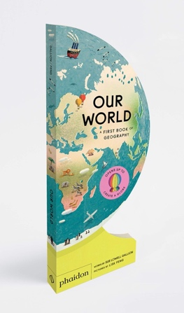

Our World, a First Book of Geography written by Sue Gallion
and illustrated by Lisk Feng is available from Phaidon Books
wherever books are sold. www.phaidon.com.

Activity sheet content copyright © 2020 by Marcie Colleen. Available free of charge for educational use only; may not be published or sold without express written permission.

